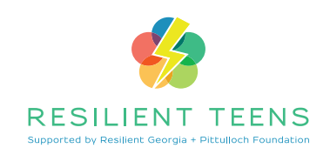

APPLICATION FORM

Student Name:
Home Address:
Phone:
School attended:
Grade:
Age:
Gender:
Preferred pronoun:
Race:
County:
Email:
Social Media:
Interests/Hobbies:

Parents/Guardian Name:
Email:
Phone:
Other Contact Information:
Work Phone:
Work Email:
We need at least 2 alternate methods of getting in touch with students for this program.
_____________________________________________________________

_____________________________________________________________

Why I would like to be in the Resilient Teen Program. Write a short essay. 300 words maximum.

This project is brought to you by Family Connection - Augusta University - MCG Foundation Community Foundation of the CSRA - Pittulloch Foundation

